Gulf Islands National Seashore
1801 Gulf Breeze Parkway
Gulf Breeze, FL 32563

850-934-2600 Florida
228-230-4100 Mississippi
www.nps.gov/guis
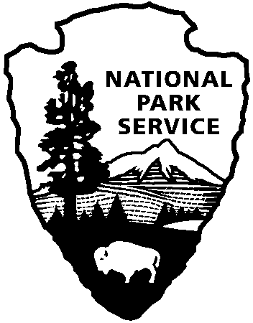
National Park Service
U.S. Department of the Interior

Gulf Islands News Release

Release Date: Immediate
Contacts: Brent Everitt, Brent_Everitt@nps.gov, 850-934-2612

Gulf Islands National Seashore is Continuing to Increase Recreational Access to Areas of the Park
The Fort Pickens Area is set to reopen, along with other Florida areas, with modified operations.
Gulf Breeze, Fla. – Following guidance from the White House, Centers for Disease Control and Prevention (CDC), and state and local public health authorities, Gulf Islands National Seashore is increasing recreational access at the Florida areas. The National Park Service (NPS) is working servicewide with federal, state, and local public health authorities to closely monitor the COVID-19 pandemic and using a phased approach to increase access on a park-by-park basis.
Beginning on Saturday, May 16, Gulf Islands National Seashore will initiate Phase Two access at:
- The Fort Pickens Area
  - Regular operating hours
  - Restrooms will be limited to Langdon Beach and the restrooms outside of the Discovery Center
  - Lifeguards will be on duty at Langdon Beach
- The Perdido Key Area
  - Regular operating hours resume
  - Lifeguards will be on duty at Johnson Beach
- Santa Rosa Area, including Highway 399
  - Opal Beach restrooms at clusters C & D will be open
  - Lifeguards will be on duty at Opal Beach
- The Okaloosa Area
  - Restrooms will be open
- The Naval Live Oaks Area
  - No restrooms
- Pensacola Bay Cruises
  - Modified operations, please visit www.cruisepb.com for details

Beginning on Saturday, May 23, additional services will resume including:
- Free tram service at the Fort Pickens Area
- Pensacola Bay Cruises will drop-off and pick-up passengers at the Fort Pickens Area

-More-

With public health in mind, the following facilities remain closed at this time:
- The Fort Barrancas Area
- The Fort Pickens Campground, Discovery Center, and bookstore
- The headquarters indoor exhibits at the Naval Live Oaks Area
- Parking lots 33A & 36A along Highway 399 (closed for the season)
- Parking lots 34A & 34E at the Opal Beach Complex
“Park staff, in coordination with public health officials continue to monitor health data from local and regional areas to determine when gating criteria is met,” said Superintendent Dan Brown. “As the areas evaluated continue to move through the required criteria the park is working hard to increase recreational access in a safe and responsible way.”

The health and safety of our visitors, employees, volunteers, and partners continues to be paramount. At Gulf Islands National Seashore, our operational approach will be to examine each facility function and service provided to ensure those operations comply with current public health guidance and will be regularly monitored. We continue to work closely with the NPS Office of Public Health using CDC guidance to ensure public and workspaces are safe and clean for visitors, employees, partners, and volunteers.
While these areas are accessible for visitors to enjoy, a return to full operations will continue to be phased and services will be limited. When recreating, the public should follow local area health orders, practice Leave No Trace principles, avoid crowding and avoid high-risk outdoor activities.

The CDC has offered guidance to help people recreating in parks and open spaces prevent the spread of infectious diseases. We will continue to monitor all park functions to ensure that visitors adhere to CDC guidance for mitigating risks associated with the transmission of COVID-19 and take any additional steps necessary to protect public health.

Details and updates on park operations will continue to be posted on our website www.nps.gov/guis and social media channels. Updates about NPS operations will be posted on www.nps.gov/coronavirus.

About Gulf Islands National Seashore: Created in 1971, the national seashore stretches 160 miles along the northern coast of the Gulf of Mexico in Florida and Mississippi, and includes barrier islands, maritime forests, historic forts, bayous, and marine habitat. Visit us at www.nps.gov/guis, on Facebook www.facebook.com/GulfIslandsNPS, Twitter www.twitter.com/GulfIslandsNPS, Instagram www.Instagram.com/GulfIslandsNPS.

About the National Park Service: More than 20,000 National Park Service employees care for America's 419 national parks and work with communities across the nation to help preserve local history and create close-to-home recreational opportunities. Visit us at www.nps.gov, on Facebook www.facebook.com/nationalparkservice and Twitter www.twitter.com/natlparkservice.
-NPS-

