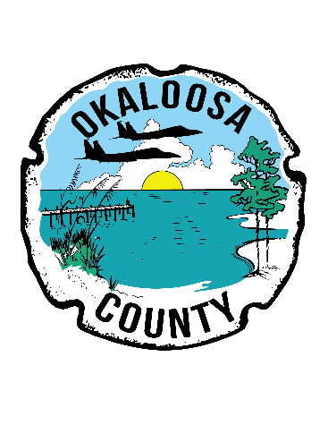
Public Notice
Board of County Commissioners
07.12.19

3rd Street and 8th Street Closed
Shalimar – Public Works Department has advised that the intersection 3rd and 8th Street in Shalimar is closed due to water in the road. Barricades have been placed for public safety.
Please avoid this area at this time.

FOR MORE INFORMATION CONTACT CHRISTOPHER SAUL 585-7059 OR AT CSAUL@MYOKALOOSA.COM

